Resultados Aoki Velloso e Decourt Quaresma

# Dados de Entrada

Lista Nspt:  
   
 [3, 1, 1, 3, 6, 10, 11, 16, 50, 50, 50, 50]  
   
 Tipo de Estaca: Hélice Contínua  
  
 Diâmetro da Estaca: 30.0 cm  
  
 Carga Admissível Esperada: 100.0 kN  
  
 Nível d'água: 8.0 m

# Resultados Aoki Velloso

Figura 1: Gráfico dos resultados pelo método de Aoki Velloso.

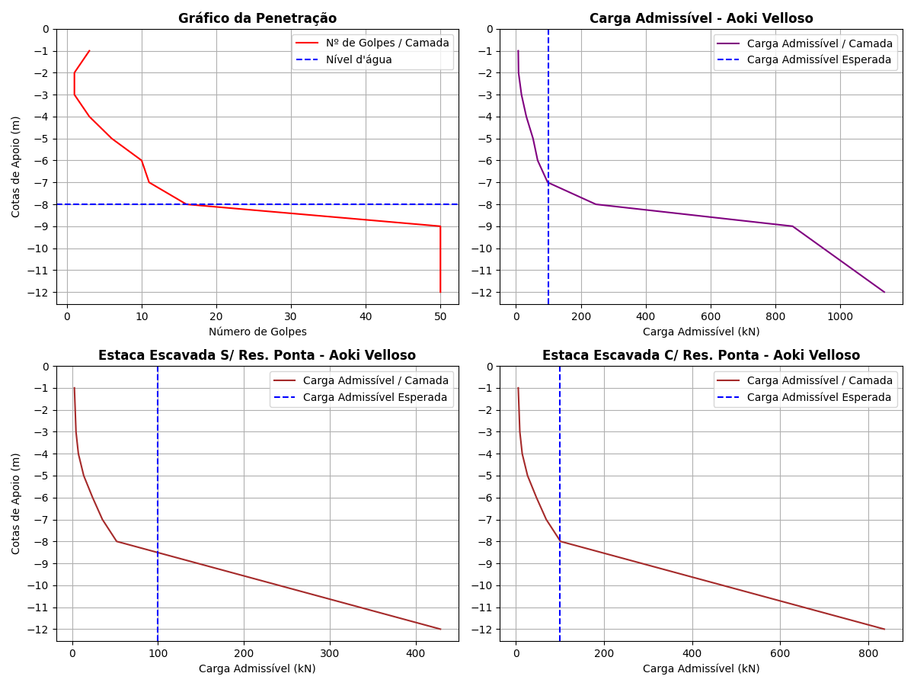

Tabela 1: Resultados pelo método de Aoki Velloso.

|  |  |  |  |  |  |  |  |  |  |  |  |
| --- | --- | --- | --- | --- | --- | --- | --- | --- | --- | --- | --- |
| Cotas | K (kPa) | α (%) | rp (kPa) | Rp (kN) | rl (kPa) | Rl (kN) | Rl Acum. (kN) | Rt (kN) | Padm (kN) | Padm Escavada S/Res. Ponta (kN) | Padm Escavada C/Res. Ponta (kN) |
| -1 | 230 | 3.4 | 115.0 | 8.13 | 5.87 | 5.53 | 5.53 | 13.66 | 6.83 | 2.76 | 5.39 |
| -2 | 230 | 3.4 | 115.0 | 8.13 | 1.96 | 1.85 | 7.38 | 15.51 | 7.76 | 3.69 | 7.2 |
| -3 | 230 | 3.4 | 345.0 | 24.39 | 1.96 | 1.85 | 9.23 | 33.62 | 16.81 | 4.62 | 9.0 |
| -4 | 230 | 3.4 | 690.0 | 48.77 | 5.87 | 5.53 | 14.76 | 63.53 | 31.76 | 7.38 | 14.39 |
| -5 | 220 | 4.0 | 1100.0 | 77.75 | 13.2 | 12.44 | 27.2 | 104.95 | 52.48 | 13.6 | 26.52 |
| -6 | 220 | 4.0 | 1210.0 | 85.53 | 22.0 | 20.73 | 47.93 | 133.46 | 66.73 | 23.96 | 46.73 |
| -7 | 220 | 4.0 | 1760.0 | 124.41 | 24.2 | 22.81 | 70.74 | 195.15 | 97.58 | 35.37 | 68.97 |
| -8 | 220 | 4.0 | 5500.0 | 388.77 | 35.2 | 33.18 | 103.92 | 492.69 | 246.34 | 51.96 | 101.32 |
| -9 | 800 | 2.0 | 20000.0 | 1413.72 | 200.0 | 188.5 | 292.42 | 1706.14 | 853.07 | 146.21 | 285.11 |
| -10 | 800 | 2.0 | 20000.0 | 1413.72 | 200.0 | 188.5 | 480.92 | 1894.64 | 947.32 | 240.46 | 468.9 |
| -11 | 800 | 2.0 | 20000.0 | 1413.72 | 200.0 | 188.5 | 669.42 | 2083.14 | 1041.57 | 334.71 | 652.68 |
| -12 | 800 | 2.0 | 20000.0 | 1413.72 | 200.0 | 188.5 | 857.92 | 2271.64 | 1135.82 | 428.96 | 836.47 |

# Resultados Decourt Quaresma

Figura 2: Gráfico dos resultados pelo método de Decourt Quaresma.

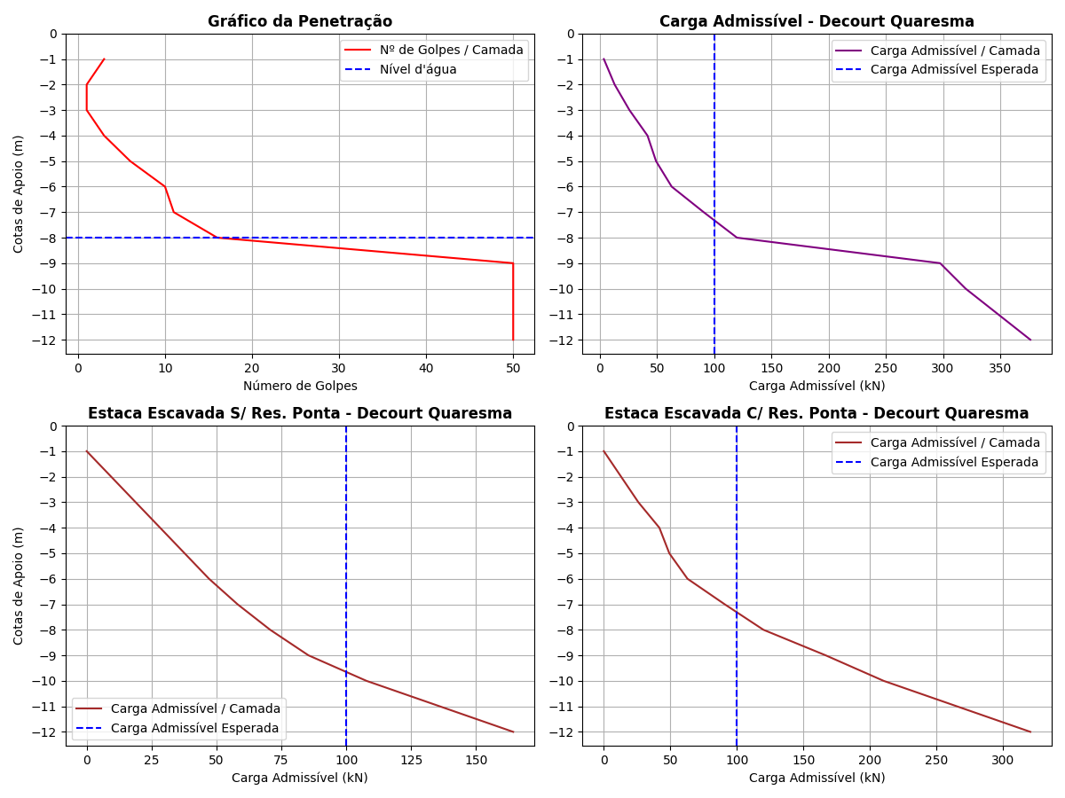

Tabela 2: Resultados pelo método de Decourt Quaresma.

|  |  |  |  |  |  |  |  |  |  |  |  |  |  |  |
| --- | --- | --- | --- | --- | --- | --- | --- | --- | --- | --- | --- | --- | --- | --- |
| Cotas | Nsptl | Nsptp | C (kPa) | α | β | rp (kPa) | Rp (kN) | rl (kPa) | Rl (kN) | Rl Acum. (kN) | Rt (kN) | Padm (kN) | Padm Escavada S/Res. Ponta (kN) | Padm Escavada C/Res. Ponta (kN) |
| -1 | 3.0 | 1.67 | 200 | 0.3 | 1 | 334.0 | 7.08 | 0.0 | 0.0 | 0.0 | 7.08 | 3.54 | 0.0 | 0.0 |
| -2 | 3.0 | 1.67 | 200 | 0.3 | 1 | 334.0 | 7.08 | 20.0 | 18.85 | 18.85 | 25.93 | 12.96 | 9.43 | 12.96 |
| -3 | 3.0 | 3.33 | 200 | 0.3 | 1 | 666.0 | 14.12 | 20.0 | 18.85 | 37.7 | 51.82 | 25.91 | 18.85 | 25.91 |
| -4 | 3.0 | 6.33 | 200 | 0.3 | 1 | 1266.0 | 26.85 | 20.0 | 18.85 | 56.55 | 83.4 | 41.7 | 28.28 | 41.7 |
| -5 | 3.0 | 9.0 | 120 | 0.3 | 1 | 1080.0 | 22.9 | 20.0 | 18.85 | 75.4 | 98.3 | 49.15 | 37.7 | 49.15 |
| -6 | 3.0 | 12.33 | 120 | 0.3 | 1 | 1479.6 | 31.38 | 20.0 | 18.85 | 94.25 | 125.63 | 62.82 | 47.12 | 62.82 |
| -7 | 4.0 | 25.67 | 120 | 0.3 | 1 | 3080.4 | 65.32 | 23.33 | 21.99 | 116.24 | 181.56 | 90.78 | 58.12 | 90.78 |
| -8 | 5.0 | 38.67 | 120 | 0.3 | 1 | 4640.4 | 98.4 | 26.67 | 25.14 | 141.38 | 239.78 | 119.89 | 70.69 | 119.89 |
| -9 | 6.38 | 50.0 | 400 | 0.3 | 1 | 20000.0 | 424.12 | 31.27 | 29.47 | 170.85 | 594.97 | 297.48 | 85.42 | 166.58 |
| -10 | 11.22 | 50.0 | 400 | 0.3 | 1 | 20000.0 | 424.12 | 47.4 | 44.67 | 215.52 | 639.64 | 319.82 | 107.76 | 210.13 |
| -11 | 15.0 | 50.0 | 400 | 0.3 | 1 | 20000.0 | 424.12 | 60.0 | 56.55 | 272.07 | 696.19 | 348.1 | 136.04 | 265.27 |
| -12 | 15.0 | 50.0 | 400 | 0.3 | 1 | 20000.0 | 424.12 | 60.0 | 56.55 | 328.62 | 752.74 | 376.37 | 164.31 | 320.4 |

# Comparativo entre Aoki Velloso e Decourt Quaresma

Figura 3: Comparativo entre Aoki Velloso e Decourt Quaresma.

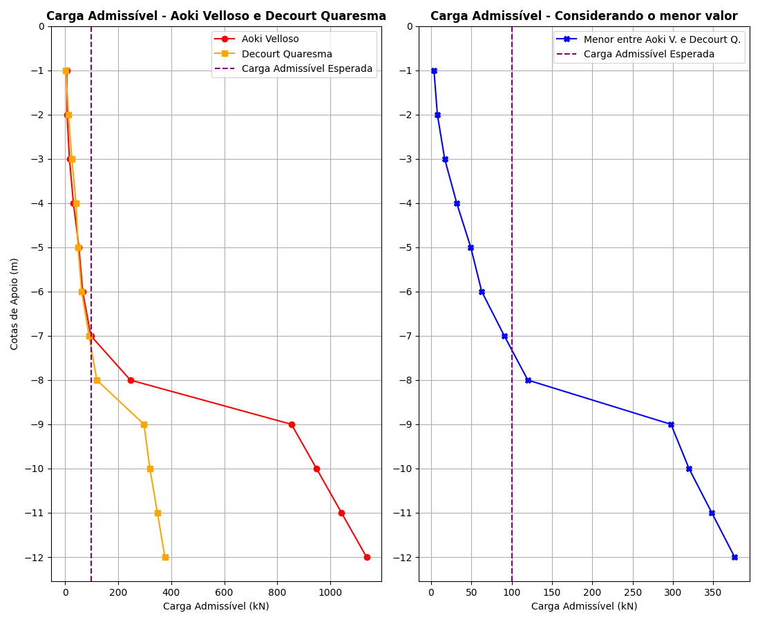

Tabela 3: Comparativo entre Aoki Velloso e Decourt Quaresma.

|  |  |  |  |
| --- | --- | --- | --- |
| Cotas | Padm - Aoki Velloso (kN) | Padm - Decourt Quaresma (kN) | Menor valor entre os métodos (kN) |
| -1 | 6.83 | 3.54 | 3.54 |
| -2 | 7.76 | 12.96 | 7.76 |
| -3 | 16.81 | 25.91 | 16.81 |
| -4 | 31.76 | 41.7 | 31.76 |
| -5 | 52.48 | 49.15 | 49.15 |
| -6 | 66.73 | 62.82 | 62.82 |
| -7 | 97.58 | 90.78 | 90.78 |
| -8 | 246.34 | 119.89 | 119.89 |
| -9 | 853.07 | 297.48 | 297.48 |
| -10 | 947.32 | 319.82 | 319.82 |
| -11 | 1041.57 | 348.1 | 348.1 |
| -12 | 1135.82 | 376.37 | 376.37 |